SOFTWARE TESTING REPORT
Practical 5 – Book Management System Bug Reports
Module Name: Book Management System
Report id: Bug 01 – 05
Website Url: https://eclectic-paletas-5f7b74.netlify.app/https://eclectic-paletas-5f7b74.netlify.app
Bug Report Summary
Total Bugs | Status: Closed | Retest: Pass | Module
5 | 5 | 5 | Book Management

Purpose
This report documents the bug scenarios, reproduction steps, expected and actual results, resolution, retest status, and remarks for the Book Management System. Screenshot evidence will be added manually by the tester.

BUG REPORT
BUG-01 – Search Book Error
Bug ID | BUG-01
Bug Summary | Search Book Error
Module Name | Book Management
Severity | Medium
Priority | Medium
Steps to Reproduce | Run program; select Search Book; enter unavailable book name
Expected Result | Display “Book not found.”
Actual Result | Book not found message displayed
Assigned To | Rudra
Status | Closed
Resolution | Working as expected
Retest Status | Pass
Remarks | Search feature tested
ScreenShots:
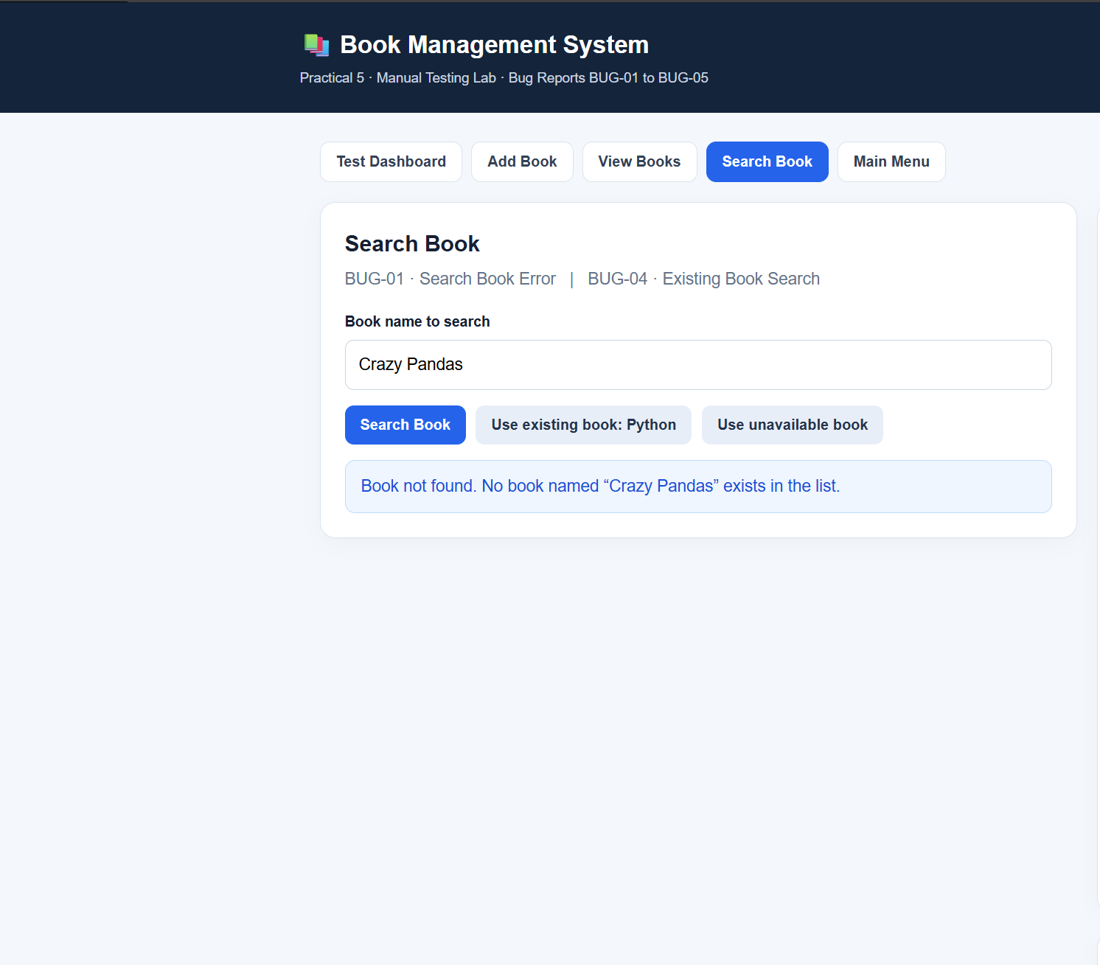
BUG REPORT
BUG-02 – Add Book Error
Bug ID | BUG-02
Bug Summary | Add Book Error
Module Name | Book Management
Severity | Low
Priority | Low
Steps to Reproduce | Run program; select Add Book; enter book name
Expected Result | Book added successfully
Actual Result | Book added successfully
Assigned To | Rudra
Status | Closed
Resolution | Working as expected
Retest Status | Pass
Remarks | Add book feature tested
Screenshots:
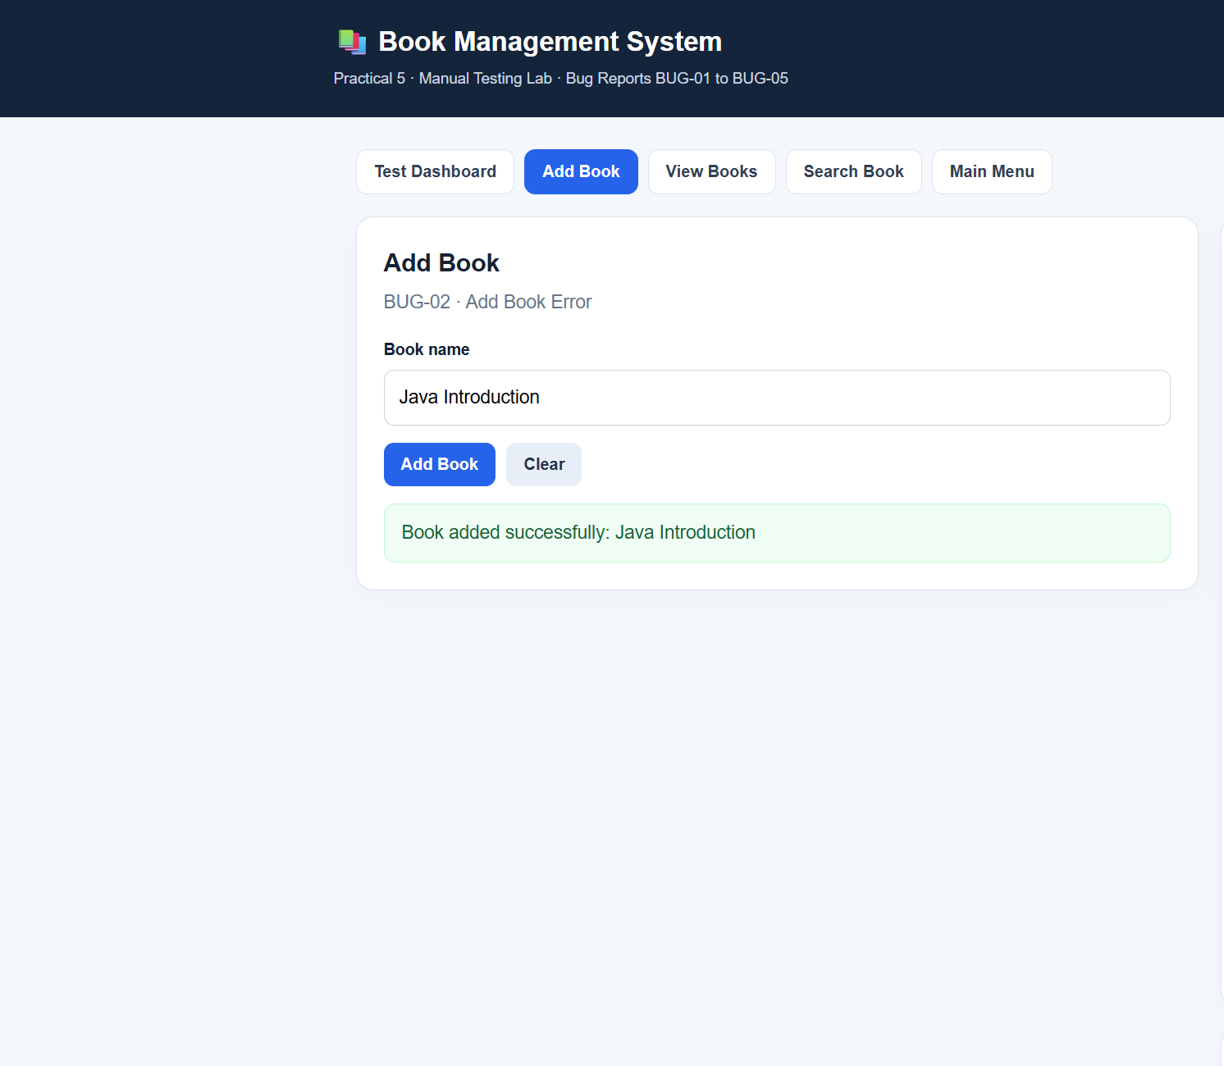

BUG REPORT
BUG-03 – View Books Error
Bug ID | BUG-03
Bug Summary | View Books Error
Module Name | Book Management
Severity | Low
Priority | Low
Steps to Reproduce | Run program; add a book; select View Books
Expected Result | Added books displayed
Actual Result | Book list displayed correctly
Assigned To | Rudra
Status | Closed
Resolution | Working as expected
Retest Status | Pass
Remarks | View books feature tested
Screenshot Evidence
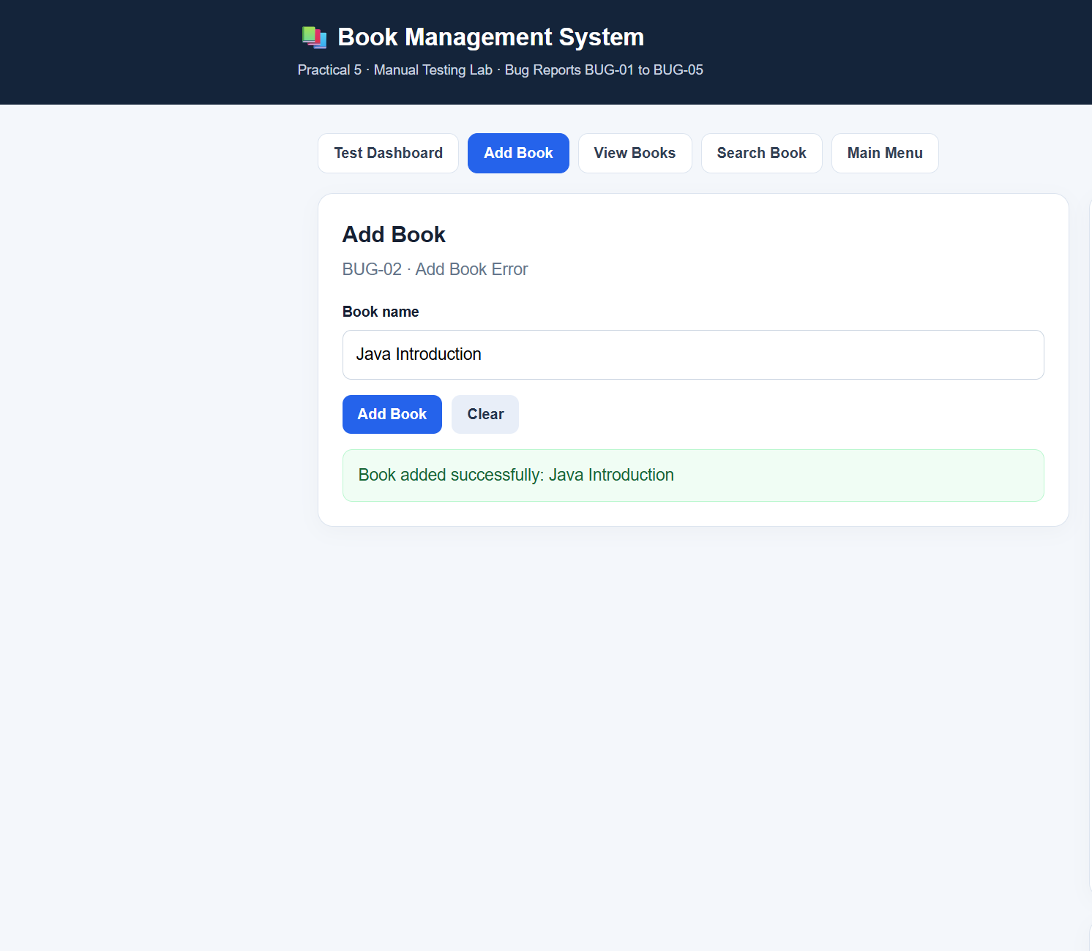
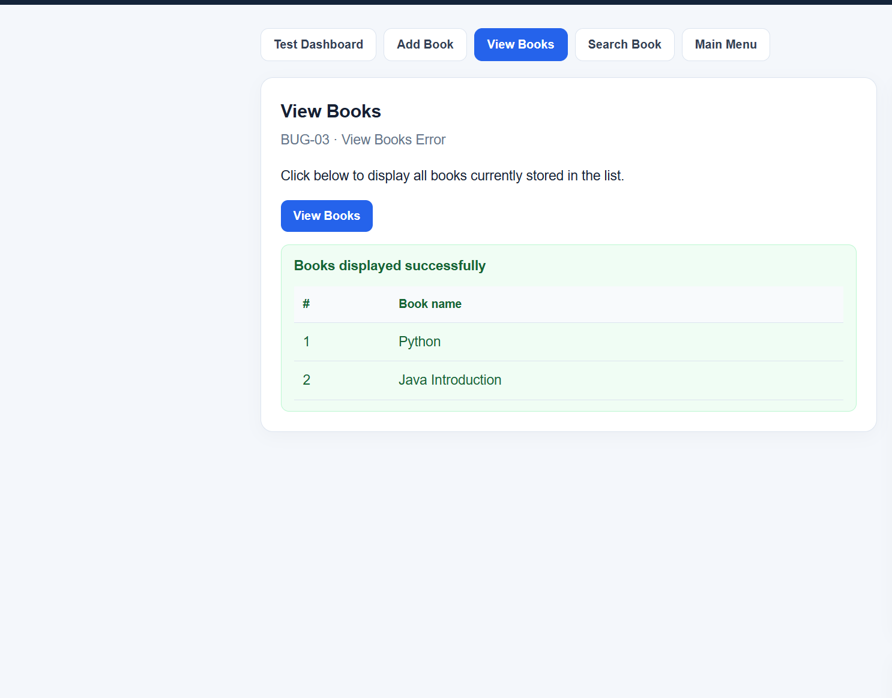
BUG REPORT
BUG-04 – Existing Book Search
Bug ID | BUG-04
Bug Summary | Existing Book Search
Module Name | Book Search
Severity | Medium
Priority | Medium
Steps to Reproduce | Run program; add Python; select Search Book; enter Python
Expected Result | Display “Book found!”
Actual Result | Book found message displayed
Assigned To | Rudra
Status | Closed
Resolution | Working as expected
Retest Status | Pass
Remarks | Existing book search tested
ScreenShots:
es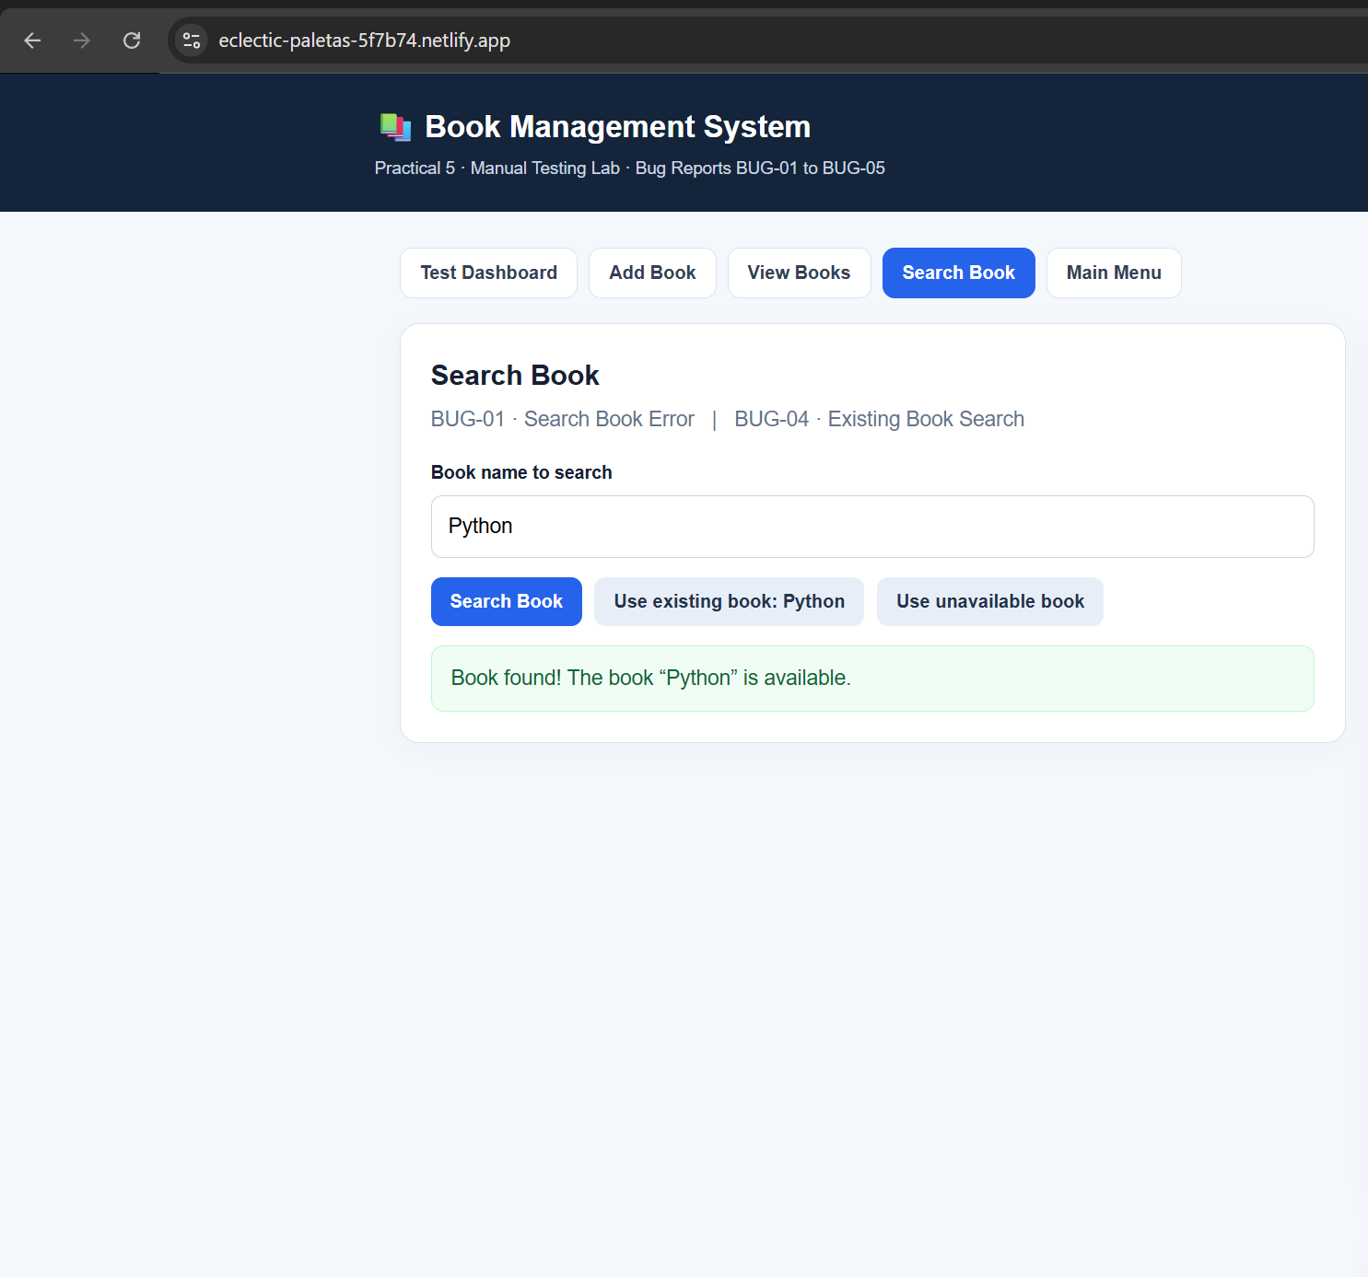
BUG REPORT
BUG-05 – Invalid Menu Choice
Bug ID | BUG-05
Bug Summary | Invalid Menu Choice
Module Name | Main Menu
Severity | Low
Priority | Low
Steps to Reproduce | Run program; enter invalid menu choice
Expected Result | Display an error message
Actual Result | Invalid choice displayed
Assigned To | Rudra
Status | Closed
Resolution | Working as expected
Retest Status | Pass
Remarks | Invalid input handling tested
Screenshots:
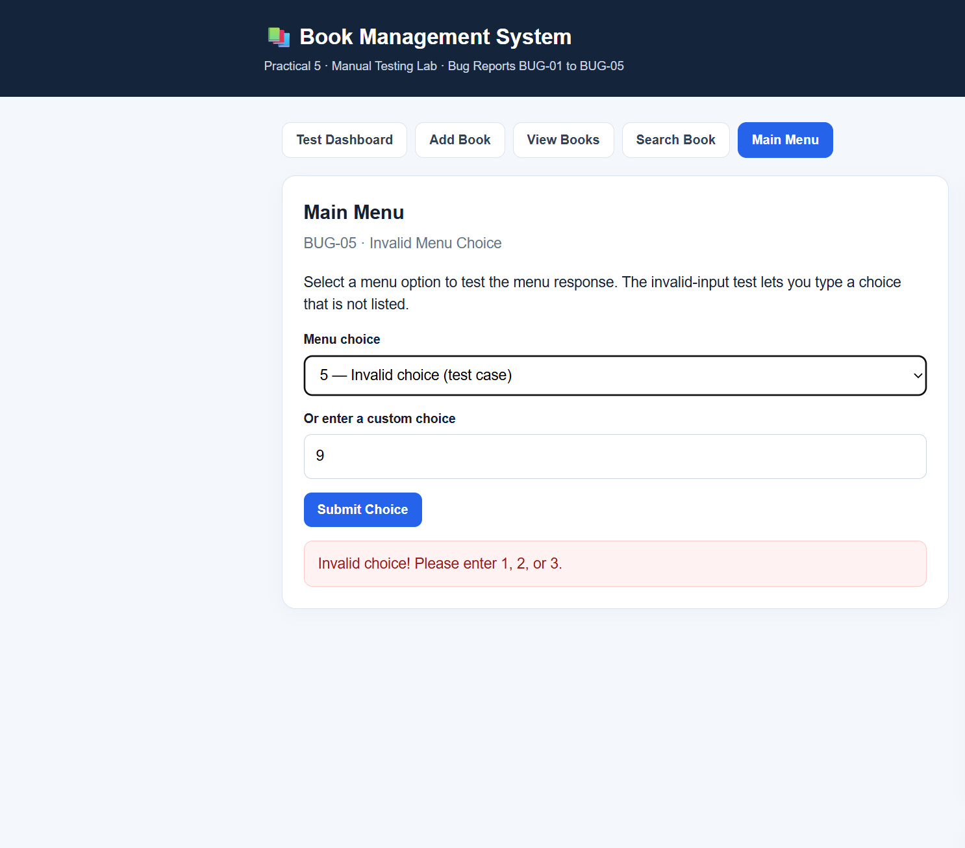
Conclusion and Recommendations
The report combines five bug reports for the Book Management System. The provided sheet records all five reports as Closed, with resolution “Working as expected” and retest status Pass.
Recommendation: Retain screenshots for each bug, repeat the test steps during retesting, and update the bug status and resolution if the actual behavior differs from the expected result.

